**Lab 3 -Fixing the discrepancy in the Review Table**

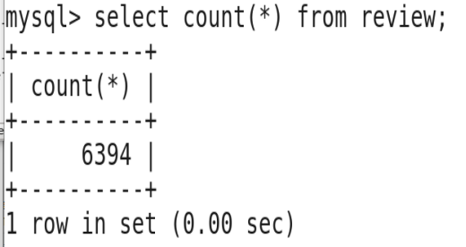

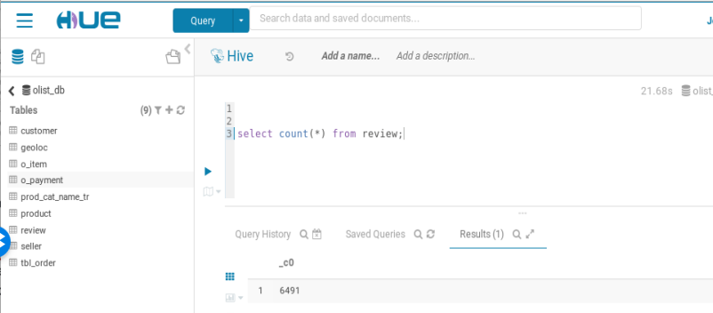

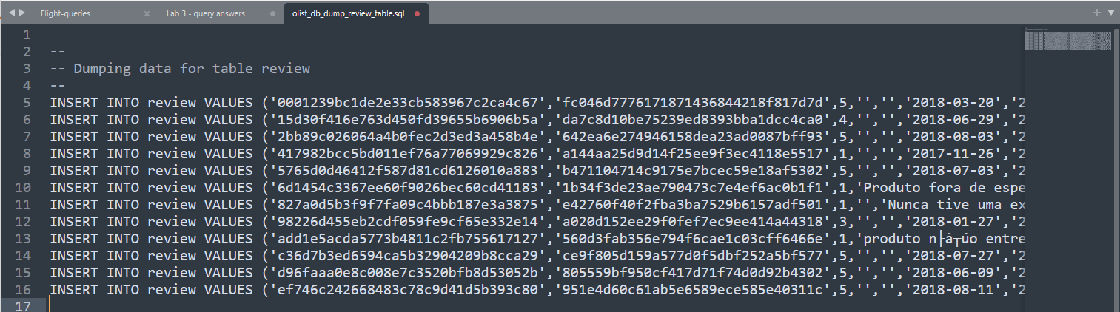

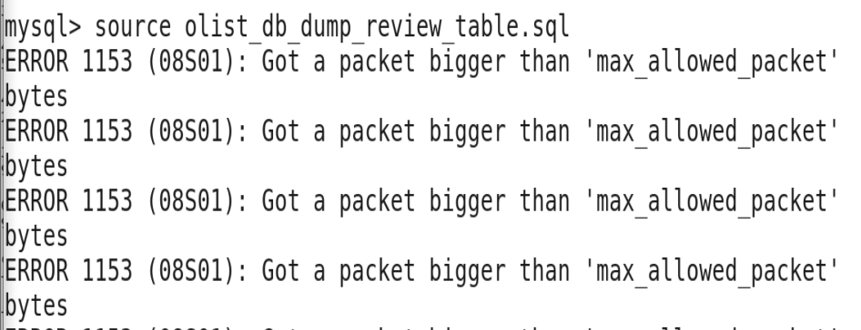

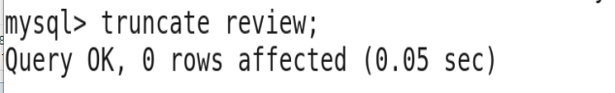

set global net_buffer_length=1000000;

set global max_allowed_packet=1000000000;

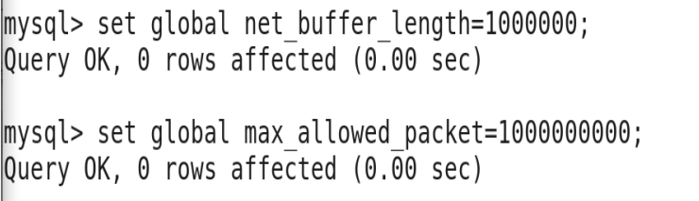

enter in the mysql terminal: *exit*

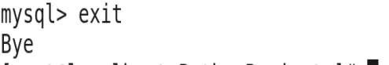

mysql --max_allowed_packet=100M -utraining -ptraining

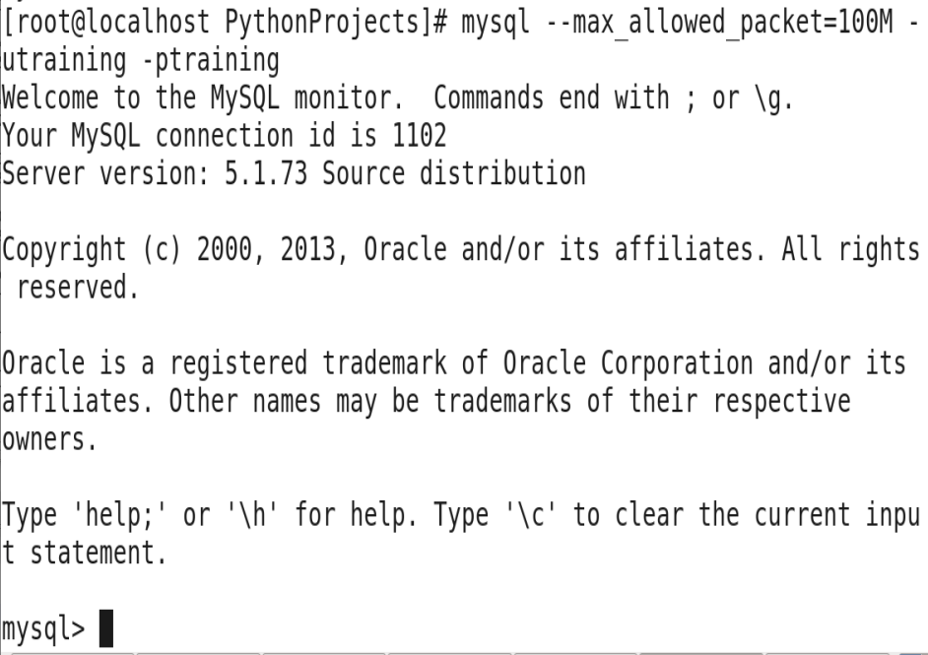

select the olist_db database: use *olist_db;*

If you enter: *DESCRIBE review;*

You’ll see that it is not big enough to get the entire review information because it has a length of 45 characters only VARCHAR(45). We can change this in the table by altering the schema for the table. First we will erase all the data in the table using *TRUNCATE:*

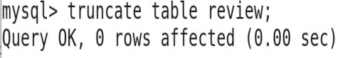

Next we will modify the length of the review_comment_title and the review_comment_message:

mysql > *alter table review modify column review_comment_title varchar (3000);*

mysql > *alter table review modify column review_comment_message varchar (3000);*

*If we were to look at the DESCRIBE review command we see now it can be as large as 3000 characters.*

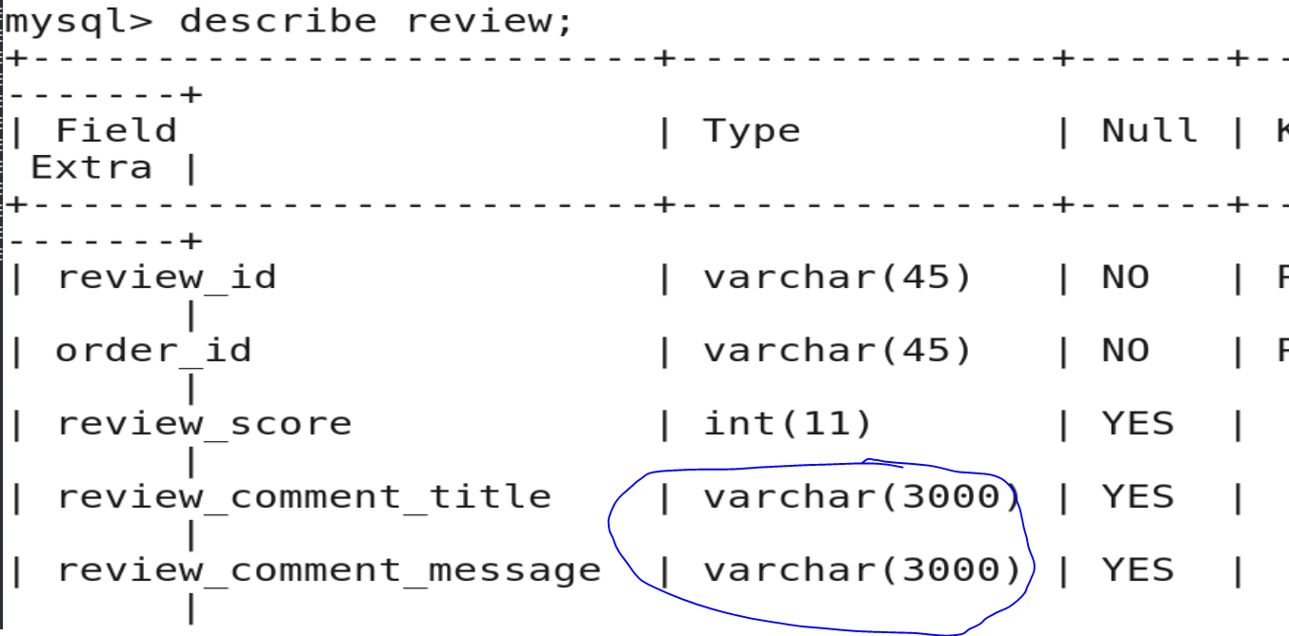

*We will reinsert the data into the Review table:*

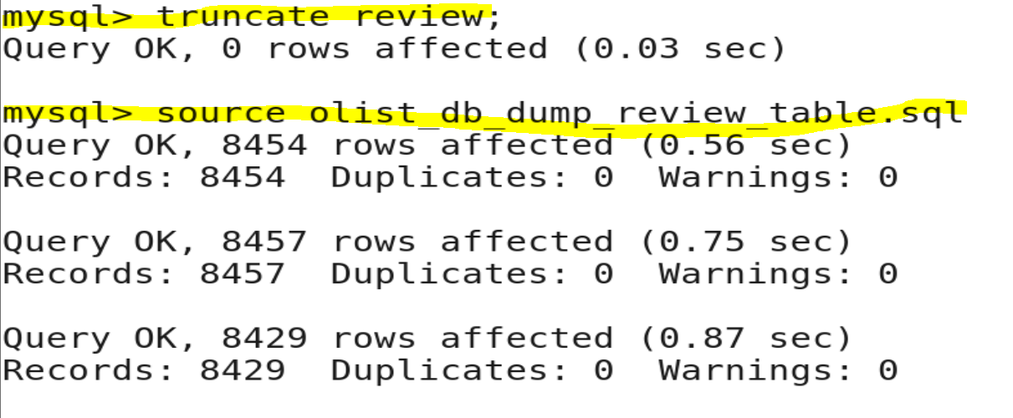

Reload the review table: *source olist_db_dump_review_table.sql*

*Check if all the data was inserted:*

*select count(*) from review:*

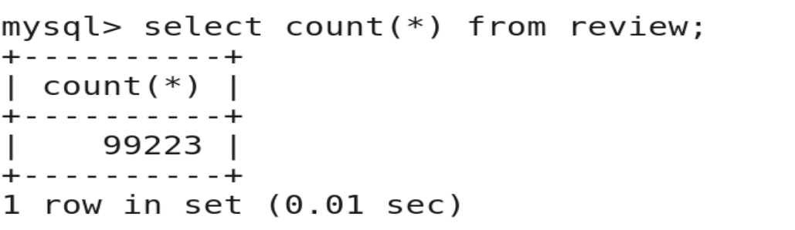

We are going to delete the review table from Hive and we will recreate it:

In the terminal > hdfs dfs -ls /user/hive/warehouse/

These is where the HIVE tables are created.

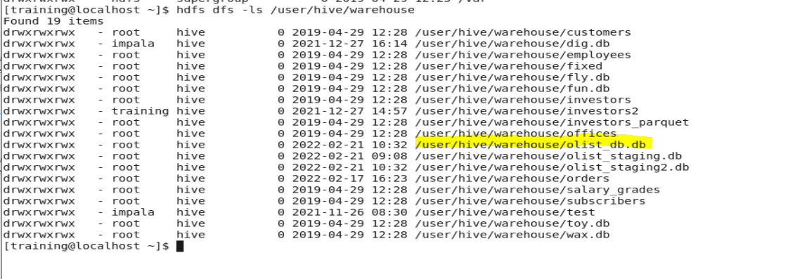

We will remove the review table in Hive:

In the terminal > hdfs dfs -ls /user/hive/warehouse/olist_db.db

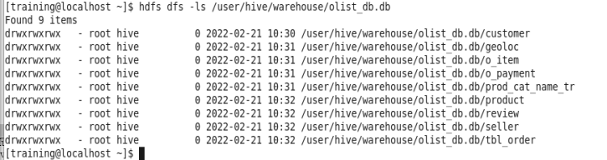

In the terminal > hdfs dfs -rm -r /user/hive/warehouse/olist_db.db/review



Now we are going to use Sqoop to reupload the “Review” table to HIVE:

sqoop import --connect jdbc:mysql://localhost/olist_db --username training --password training --table review -m 1 --hive-import --create-hive-table --hive-table review --target-dir /user/hive/warehouse/olist_db.db/review --enclosed-by '\"' --fields-terminated-by , --escaped-by \\

sqoop import --connect jdbc:mysql://localhost/olist_db --username training --password training --table review -m 1 --hive-import --create-hive-table --hive-table review --target-dir /user/hive/warehouse/olist_db.db/review --fields-terminated-by , --escaped-by \\ --optionally-enclosed-by '\"'